Sidewalk Closed
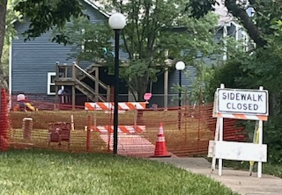
Please be advised that the Section of Sidewalk off 125th Street is closed until further notice.
It was discovered that the Storm Water Drainage Area has caused a sink hole and the City Stormwater Department has been notified and they will be making the necessary repairs in the future.
Please stay away from this area.

